CANADIAN COUNCIL OF BETTER BUSINESS BUREAUS

ANNUAL REPORT

2001 – 2002

April 1st, 2002

The Better Business Bureau system aims to be the largest business ethics organization in Canada and the United States

VISION….

To be the major information source for ethical business and advertising practices

MISSION….

To promote and encourage outstanding ethical relationships between business and the public

VALUES….

To adhere to the values of excellence, integrity, teamwork, trust, respect and accountability

GOAL….

To follow strategic directions for the Better Business Bureau system as a team of professionals, united by a commitment to a common vision, mission and values

Message from the Chair

The past year has been a challenging one for the Canadian Council of Better Business Bureaus. In May of 2001, the Council was forced to terminate the membership of the Better Business Bureau of Metropolitan Toronto, which once had been the largest and strongest bureau in the country. Since that time, a substantial part of our time and resources have been devoted to dealing with the issues arising from that termination.

I would like to acknowledge and thank our national members for their continued involvement. The Canadian Council is supported almost entirely by these memberships. Not only is their financial support crucial, but the time and expertise of national member directors on our Board has been extremely beneficial.

Our appreciation is due, also, to the Better Business Bureaus located in Kitchener, Ottawa and Hamilton, all of which have worked very hard in the past year to deal with consumer inquiries from the Greater Toronto area.

Membership in the Bureau system in Canada is strong and growing, and I know that the 14 Better Business Bureaus across Canada, together with the Canadian Council, provide a valuable service to Canadian consumers and business. I look forward in the next year to the re-establishment of a strong better Business Bureau in Metropolitan Toronto, and to expansion of the service we are proud to provide.

David Brander
Chairman of the CCBBB Board of Directors

Message from the President

The Annual Report provides an ideal opportunity to reflect on the Council’s activities during the last year. There are several ways to measure the accomplishments during the past 12 months including overall growth in the national office and local bureaus, introduction and growing use of the online reports and consumer information links, increased public awareness through media interest and contact, and the ability to deal with all payments on a current basis.

In my opinion two areas stand out. The first is the opportunity to visit the 14 Canadian bureaus and meet with staff, board members, and community supporters. The visits also allowed time to meet with national member organizations that support the Council, as well as meetings with prospective members in different parts of Canada. The second key area, during a year of significant business challenges because of the economy and September 11th, was renewals and additions to national membership. At the start of the year there were 40 national members and the CCBBB accepted nine new national members. Three members decided not to renew. Current national membership is 46 representing a 15% increase.

During the past year the CCBBB web-site, started in 2000, was expanded and refined to meet consumer and business needs in Canada and internationally. Recent statistics show more than 500 visits a day to the site with links to the bureau system and to consumer reports. Throughout the Canadian bureau system there were 1.7 million instances of service and inquiry (does not include website access); 900,000 reliability reports on companies; 16,000 written complaints resolved; and with BBB membership in Canada at 23,300. In addition the Council office continued to develop strong connections and information exchange with the Canadian Competition Bureau, US Federal Trade Commission, Canadian and US postal services, and law enforcement groups including Phonebusters in an effort to provide increased service to consumers seeking information or complaint redress.

Our goals for the past year in the CCBBB, which still continues, was growth of the Better Business Bureau system through awareness of the BBB standards; accessibility to BBB information; service to consumers, members, and businesses; and, increased local and national membership.

Bob Whitelaw
President and CEO

The Better Business Bureau System – Then and Now

From the late 1800’s when responsible advertising was in the hands of the paper media, to the 1900’s when volunteers took up the challenge to expose less than ethical advertisers and suspicious schemes, followed the decades of the 20th century when advertising expanded. It then became essential to have acceptable standards of honesty for the marketplace.

The influence of the Coca Cola company’s president, Samuel C. Dobbs, making a case for ethical advertising, was significant, and then came the creation of vigilance committees in 1912 that evolved into the National Better Business Bureau. As the BBB continued to gain recognition in the United States, with a reference guide for advertisers, the torch logo in 1962, and amalgamation of two associations to form the Council of Better Business Bureaus (CBBB) in 1970, there was a newer version of the organization growing north of the border.

The BBB came to Canada in 1935, and with 14 bureaus now in existence, from St. John’s, Newfoundland to Victoria, British Columbia, membership continues to grow. Recognition of the BBB as a valuable sounding board, and an organization that is people friendly and the buffer between business and the consumer, is necessary for a healthy business marketplace. Whether a local or a national member, companies can expect the same high standards of service from the offices, as can the consumers who use the service. All companies in North America, regardless of size, can submit their names for the BBB International Torch Award for Marketplace Ethics (winners announced at the Annual assembly in September), an opportunity to be recognized as a business that supports high ethics and business standards.

The Canadian Council of Better Business Bureaus (CCBBB) is pleased to provide an overview of the 2001 Canadian BBB activities:

Instances of direct service 1.7 million (excludes web-site access)
Reliability reports on companies 900,000
Written complaints resolved 16,000
BBB members throughout Canada 23,300

As Canada strives to meet the challenges of the global community, so the BBB continues to work towards improved communication in an age of electronic commerce. BBB reports, consumer inquiries, web-site access in French and English, and BBB OnLine - created to provide a reliability seal that provided verification by a “click”- are all components of our service.

Highlights in the 2001 to 2002 period – Outreach and Awareness

Outreach can probably be divided into the following sections –

Better Business Bureaus across Canada

Federal Government, Canada and the U.S.

Media (covered elsewhere in this report)

Visits to local bureaus were made at least once in 2001, with the purpose of making a visible connection with the CCBBB office, explaining what is done, and listening to staff comments on “what is working well” in their office and bureau jurisdiction.

By reaching out to various Federal Government departments and Ministries, invitations were received to be part of information sessions, think tanks, and working groups that have given a higher profile to the Better Business Bureau. Examples of involvement include:

Industry Canada - participant in public policy round table discussion on The Access to Information Act - May 2001
Federal Trade Commission, Washington, DC – meetings on advance loan schemes and the map-tracking project – July 2001
Canadian Embassy, U.S. – meetings on online reliability reports – July 2001
Industry Canada – presentation to Commissioner of the Competition Bureau and senior staff on online reliability reports and accessibility issues regarding electronic commerce – September 2001
Canadian High Commission, London, England - presentation on BBB reliability reports, and the CCBBB web-site - October 2001
Industry Canada – discussions on a National Consumer Gateway project for complaints (the focus was on complaints involving financial institutions, credit collection agencies and airlines) – various dates. Leaflet now released; check under http://ConsumerInformation.ca
Industry Canada – Office of Consumer Affairs – a participant, Consumer Complaints Management Guide Working Group, that resulted in the release of booklet, Consumer Complaints Management, A Guide for Canadian Business. There are various references to the BBB. The online version of the Guide is available at http://strategis.ic.gc.ca/SSG/ca01763e.html and reflects any changes, additions and revisions.

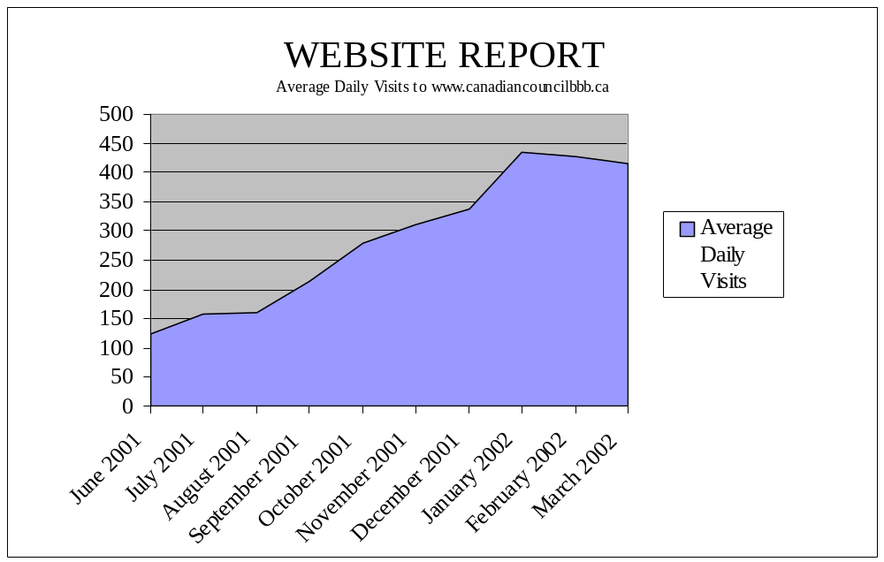

For March 2002, the Canadian Council website averaged between 500 and 600 weekday visits

More than 75,000 total visits were logged between June 2001 and March 2002

The following seven Canadian Bureaus have online reports:

Better Business Bureau of Mainland B.C. www.bbbvan.org
Better Business Bureau of Southern Alberta www.betterbusiness.ca
Better Business Bureau of Central & Southern Alberta www.edmontonbbb.org
Better Business Bureau of South-Western Ontario www.bbbwindsor.com
Better Business Bureau of Western Ontario www.bbblondon.on.ca
Better Business Bureau of Mid-Western Ontario www.bbbmwo.ca
Better Business Bureau of Eastern Ontario & the Outaouais www.easternontario.bbb.org

CCBBB - Revenues and Expenditure
Year Ending March 31, 2002
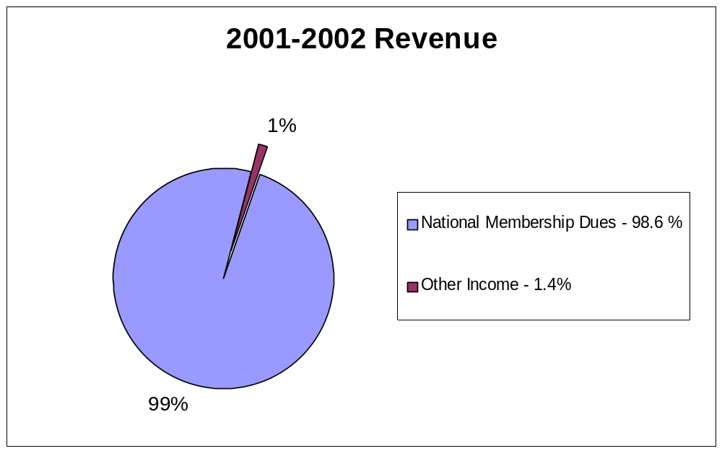

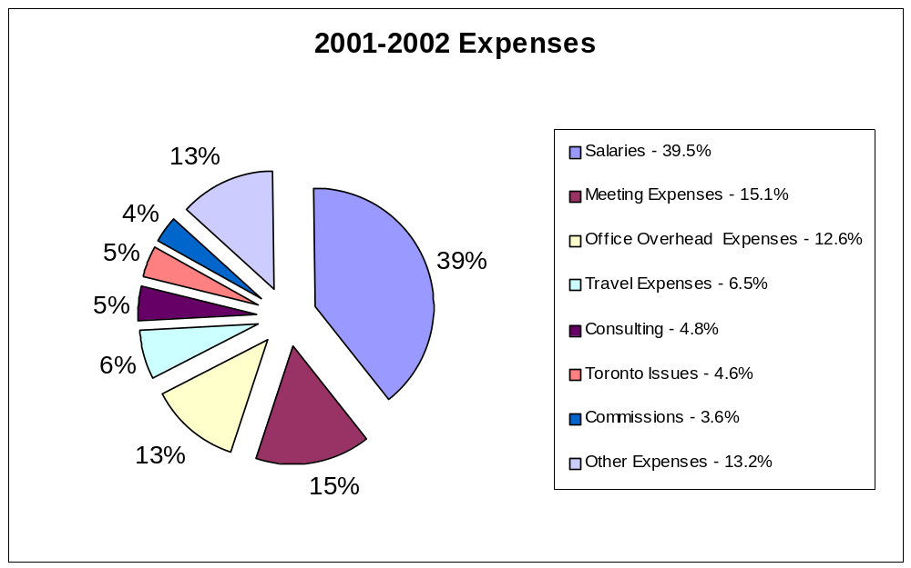

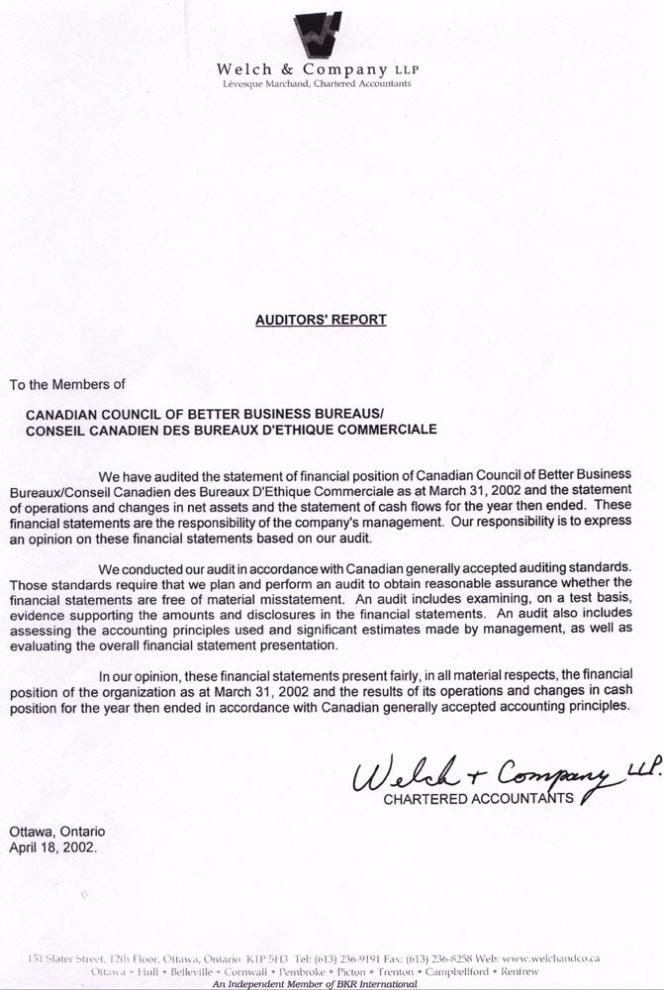

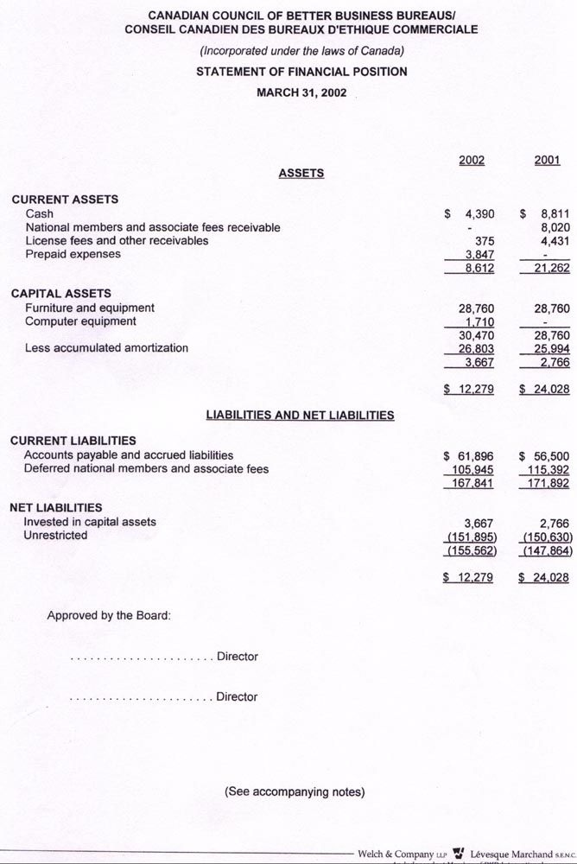

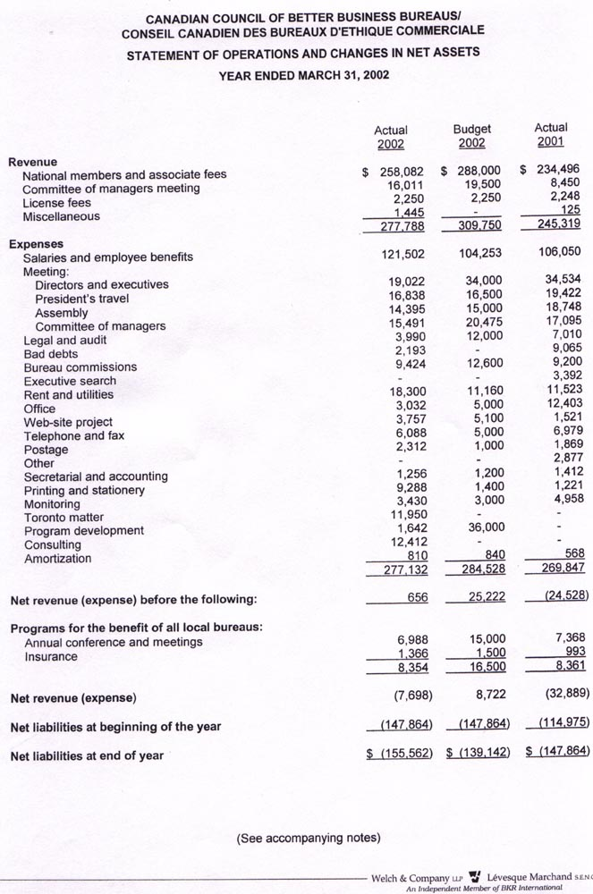

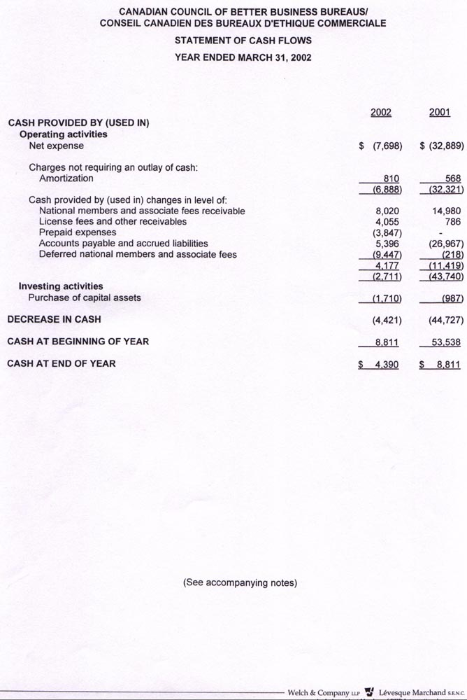

Media Watch

The importance of media support, television, radio and print, for publicizing the consumer stories that assist the public with awareness issues, cannot be underestimated. Of parallel importance is the public’s understanding of the role and purpose of the BBB, and if a news article or interview does not state or say, “check with your local” bureau, more and more readers or viewers are contacting them anyway.

During the past year, as the CCBBB president traveled to bureaus across Canada, the local staff made full use of his available time, and utilized his comfort with all types of interview by scheduling meetings with various media. Examples of newspaper articles:
The Express, St John’s Newfoundland, July 11, 01 – web-page fraud -
The Gazette, Montreal PQ, November 8, 01 – Falling For Tim J. Con –
The Ottawa Citizen, Ottawa ON, December 23, 01 – Fighting ID Theft –
Chronicle herald, Halifax NS, March 25, 02 – Fraud, Don’t Be An Easy Target –

The publicity for the local bureau with a national tie-in was helpful for both levels of the organization.

Although not as a direct result of a bureau meeting, but to see the BBB highlighted in
The Globe and Mail, “Social Studies” section, March 11, 02 – Recent Scams –
keeps the profile in the public eye.

As the CCBBB office continues to accumulate a variety of media contact people in Canada and the U.S., it is refreshing to have been contacted for comments on an increasing number of occasions.

Other examples of media coverage include:
Radio & TV Halifax, NS August 2001
CBC TV St John’s NF (nation wide) August 2001
CTV Toronto, ON September 2001
FOX TV New York September 2001
CBC radio Ottawa, ON (province wide) September & November 2001
CFAX radio Victoria, BC December 2001
CJOH Ottawa, ON frequently
NEW RO Ottawa, ON frequently
WSTM TV New York December 2001
CBC TV Toronto January 2002
WTVJ (NBC) Florida February 2002

The Top Ten Inquiries & Complaints, produced monthly as a result of all bureaus sending in their statistics, is sent as a Press Release to various media. This has proved to be a Release of great interest, and has generated the opportunity for a comment, a quote or an interview.

CANADIAN COUNCIL OF BETTER BUSINESS BUREAUS
BOARD OF DIRECTORS
2001-2002

EXECUTIVE COMMITTEE
Chair David Brander Past Chair Mark Hanley
CCBBB Scott, Petrie, Brander & Walters CCBBB Mitchells Gourmet Foods

Treasurer Brenda Watson Chair Jan Delaney
PricewaterhouseCoopers COM Committee of Managers

Vice Chair Brian Curial President Bob Whitelaw
Parlee McLaws CCBBB Canadian Council of BBBs

Vice Chair Greg Shannon
Miller Thomson

President Ken Hunter
CBBB Council of Better Business Bureaus

Chair Calvin Collier
CBBB Kraft Foods, Inc

BUREAU DIRECTORS
Vancouver Island, BC Colin Moorman Mainland of BC Garry Rolls
Cridge Centre for the Family TELUS

Southern Alberta Michael Dempster Central & Northern AB Brian Curial
Hospitality Inn Parlee McLaws

Saskatchewan Brenda Watson Manitoba Val Thompson
PricewaterhouseCoopers Frontier Subaru

Windsor & S.W. ON Peter Berry Western Ontario Rick Campbell
OB 1 Consulting Inc. University of Western Ontario

Midwestern Ontario Laverne Brubacher South Central Ontario Paul S. Dixon
Menno S. Martin Contractor Ltd Leggat, Baldwin, Keesmaat & Dixon

Ric Borski
Vice chair COM

Eastern Ontario & Tim Georgeoff Quebec Marcel Clément
the Outaouais CAA North & East Ontario Bell Canada

Maritimes Chris Matthews Newfoundland & Gordon Morgan
C.J. Matthews & Associates Ltd. Labrador Coldwell Banker Abba Realty

NATIONAL MEMBERS ON CCBBB BOARD OF DIRECTORS

Welcome Wagon Ltd. Pat Neuman Canada Post Corporation Alain Guilbert

Trans Canada Credit Floyd Croucher TD Canada Trust Chris Mariani

CANADIAN BUREAU CONTACT INFORMATION – from the West to the East coast

Canadian Council of Better Business Bureaus  44 Byward Market Square, Suite 220  Ottawa, ON K1N 7A2  Telephone: (613) 789-5151 Fax: (613) 789-7044  E-Mail: ccbbb@canadiancouncilbbb.ca  Website: www.canadiancouncilbbb.ca | Better Business Bureau of Western Ontario  616-200 Queens Avenue  London, ON N6A 1J3  Telephone: (519) 673-3222 Fax: (519) 673-5966  Toll-free (Area Code 519 Only): 1-877-283-9222  E-Mail: inquiries@bbblondon.on.ca  Website: www.bbblondon.on.ca (Online Reports)
Better Business Bureau of Vancouver Island  1005 Langley Street, Suite 201  Victoria, BC V8W 1V7  Telephone: (250) 386-6348 Fax: (250) 386-2367  E-Mail: info@bbbvanisland.org  Website: www.bbbvanisland.org | Better Business Bureau of Mid-Western Ontario  354 Charles Street East  Kitchener, ON N2G 4L5  Telephone: (519) 579-3080 Fax: (519) 570-0072  Toll-free (Area Codes 705, 519, 905, 416 Only): 1-800-459-8875  E-Mail: inquiry@bbbmwo.ca  Website: www.bbbmwo.ca (Online Reports)
Better Business Bureau of Mainland B.C.  404-788 Beatty Street  Vancouver, BC V6B 2M1  Telephone: (604) 682-2711 Fax: (604) 681-1544  E-Mail: bbbmail@bbbvan.org  Website: www.bbbvan.org (Online Reports) | Better Business Bureau of South Central Ontario  100 King Street East  Hamilton, ON L8N 1A8  Telephone: (905) 526-1111 Fax: (905) 526-1225  E-Mail: bbbsco@bellnet.ca  Website: www.bbbhamilton.com
Better Business Bureau of Southern Alberta  350-7330 Fisher Street S.E.  Calgary, AB T2H 2H8  Telephone: (403) 531-8780 Fax: (403) 640-2514  E-Mail: complaints@betterbusiness.ca  Website: www.betterbusiness.ca (Online Reports) | Better Business Bureau of Eastern Ontario and the Outaouais  603-130 Albert Street  Ottawa, ON K1P 5G4  Telephone: (613) 237-4856 Fax: (613) 237-4878  Toll-free (Area Code 613 Only): 1-877-859-8566  E-Mail: info@easternontario.bbb.org  Website: www.easternontario.bbb.org (Online Reports)
Better Business Bureau of Central & Northern Alberta  9707-110th Street, 888 Capital Place  Edmonton, AB T5K 2L9  Telephone: (780) 482-2341 Fax: (780) 482-1150  Toll-free (Province of Alberta Only): 1-800-232-7298  E-Mail: info@edmontonbbb.org  Website: www.edmontonbbb.org (Online Reports) | Better Business Bureau of Québec  785 Plymouth Avenue, Bureau 304  Ville Mont-Royal, PQ H4P 1B3  Telephone: (514) 286-9281 Fax: (514) 286-2658  Toll-free (Province of Québec Only): 1-877-286-9281  E-Mail: bbbec@bbb-bec.com  Website: www.bbb-bec.com
Better Business Bureau of Saskatchewan  201-2080 Broad Street  Regina, SK S4P 1Y3  Telephone: (306) 352-7601 Fax: (306) 565-6236  E-Mail: bbbsask@accesscomm.ca  Website: www.bbbsask.com | Better Business Bureau of the Maritimes  805-1888 Brunswick Street  Halifax, NS B3J 3J8  Telephone: (902) 422-6581 Fax: (902) 429-6457  Toll-free (Maritime Provinces Only): 1-800-422-5413  E-Mail: bbbmp@bbbmp.ca  Website: www.bbbmp.ca
Better Business Bureau of Manitoba  1030 B Empress Street  Winnipeg, MB R3G 3H4  Telephone: (204) 989-9010 Fax: (204) 989-9016  Toll-free (Province of Manitoba Only): 1-800-385-3074  E-mail : inquiries@mb.sympatico.ca  Website: www.manitoba.bbb.org | Better Business Bureau of Newfoundland & Labrador  360 Topsail Road  St. John’s, NF A1E 2B6  Telephone: (709) 364-2222 Fax: (709) 364-2255  E-Mail: info@nfldbbb.nf.ca  Website: www.nfldbbb.nf.ca
BBB of Windsor & South-Western Ontario
880 Ouellette Avenue, Suite 302
Windsor, ON N9A 1C7
Telephone: (519) 258-7222 Fax: (519) 258-1198
E-Mail: wbbb@wincom.net
Website: www.bbbwindsor.com (Online Reports)

NATIONAL MEMBER COMPANIES

- A Plus Child Development (Canada) Ltd.
- Allianz Education Funds Inc. (formerly Heritage Scholarship Trust Foundation)
- Bank of Montreal
- Bank of Nova Scotia
- BBM Bureau of Measurement
- Bell Canada
- Bridgestone/Firestone Canada Inc.
- Canada Post Corporation
- Canadian Scholarship Trust Foundation (formerly Canadian Scholarship Trust Consultants)
- Canadian Tire Corporation Ltd.
- Capital One Inc.
- Clarica Life Insurance Company
- Culligan of Canada Ltd.
- DaimlerChrysler Canada Ltd.
- Darnley Professional Training Institute Inc. (formerly Institut de formation professionnelle)
- Dynamic Circulation Inc.(The Interprovincial Circulation Group of Companies)
- Essentially Yours Industries Corp.
- Excel Telecommunications (Canada) Inc.
- Ford Motor Company of Canada Ltd.
- General Motors of Canada Ltd
- Goodyear Canada Inc.
- H & R Block Canada Inc.
- HSBC Bank Canada
- Hudson’s Bay Company
- ISDI (International Silver Development Inc.) * no longer a member of BBB
- Investors Group Inc.
- KIA Canada Inc.
- Krown Corporate (Krown Rustproofing)
- Liberty Health
- MBNA Canada Bank
- National Association Against Fraud
- National Money Mart Company
- Phone Directories Company (formerly Western Phone Directories)
- Quixtar Canada Corporation
- Scholarship Consultants of North America Ltd.
- Shaklee Canada Inc.
- The Brick Warehouse Corporation
- The Pampered Chef Canada Inc.
- Thomson Education Direct Limited (formerly ICS Canadian Limited)
- Toronto Dominion Bank Greenlight Financial Services
- Trans Canada Credit Corporation
- Vector Marketing Canada Ltd.
- VIA Rail Canada Inc.
- VISA Canada Inc.
- Welcome Wagon Ltd.
- Xentel DM Inc.
N.B. For clarification purposes heavy type is used to show the most recent company name changes.

